Norfolk Green Care Network
Constitution
(originally approved by the Network Annual Meeting on 20th October 2021 and amended via email consultation and approval of the membership prior to the Annual Meeting in October 2023)
SECTION 1: VISION, VALUES, AIMS, OBJECTIVES AND POWERS
1. NAME
1.1 The name of the organisation shall be Norfolk Green Care Network (hereinafter referred to as the Network)
2. VISION
2.1 The Network has a vision for all people living in Norfolk and surrounding areas being connected to nature, so that:
- They better understand how the natural world works* and what it is made up of
- They are able to appreciate and experience its benefits to humans in promoting health and wellbeing, and aiding recovery from illness
- They are responsible in their attitudes and behaviour towards the natural world; they try to avoid damaging it and help it to thrive
3. VALUES
3.1 The Network and its members believe and practice the following core values in seeking to achieve this vision:
- Collaborate- we will work in partnership and share information and ideas.
- Respect- we will treat each other with courtesy and tolerance, and acknowledge that all views and ideas have value, and we will stand up to any intolerance or prejudice on whatever grounds
- Inclusion - we will actively promote our work to include under-represented groups
- Compassionate-we will try to understand the circumstances of each other’s situation and be kind in how we treat each other, where possible offering help and support
- Excellence-we will strive to achieve the highest standards in what we do to deliver or promote opportunities for people to connect with nature
- Professional-we will act without personal interest and seek to deal with each other in friendly and positive ways
- Creative- we will be open minded and contribute ideas that are intended to make the Network operate effectively and efficiently
*This includes an understanding of the language of the land through the four ecosystem processes: the water cycle, the mineral cycle, community dynamics (succession) and energy flow.

4. AIMS AND OBJECTIVES
4.1 The Network’s primary aims are to support its members and others to connect with each other so as to add value to their activities and interests focused on enabling people to connect with the natural world and to promote the development of ‘green care’ activities in Norfolk and its surrounding areas.*
*the Network covers projects, organisations and activities in the County of Norfolk, Waveney District and other areas in Suffolk within 20 miles of the county boundary, and Fenland areas in Cambridgeshire and Lincolnshire within 20 miles of the county boundary.
4.2 The Network defines ‘green care’ as any activity that involves enabling people to better understand, care for and promote health and wellbeing through connecting with the natural world. It is grouped into 6 main categories, as is shown in the following diagram.
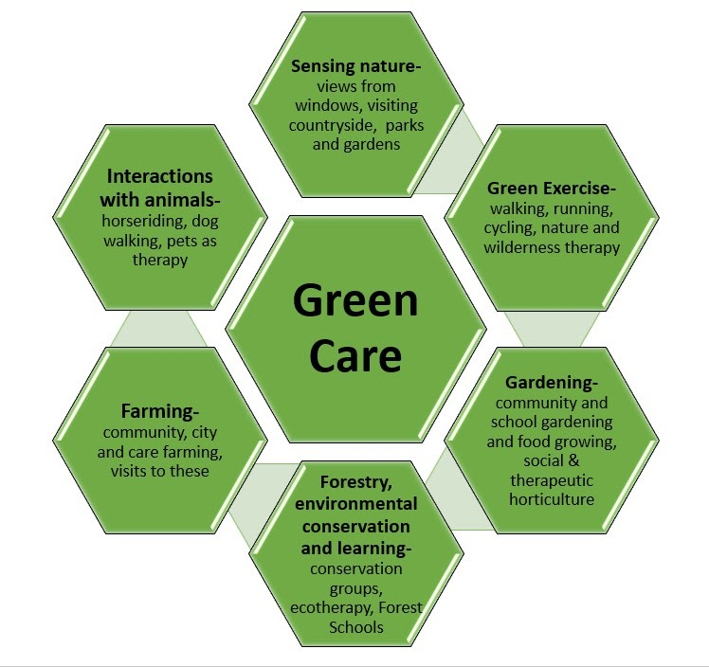
4.3 For the purpose of carrying out its primary aims, but not otherwise, the Network has the following objectives:
1. Supporting networking between members and with others, including:
- Enabling members to connect and explore potential working relationships
- Sharing expertise, resources and volunteers
- Coming together to develop expertise through training and events
- Providing pathways for individuals to progress between different types and levels of green care
2. Promoting the development of green care
- Inspiring and promoting the development of Green Care activities, including places where they don’t currently exist
- Developing a set of values and practices which ensure those involved can be seen as meeting a common set of standards, whilst recognising the variety of the activities being provided
- Bringing together and promoting research into the impact of Green Care so as to further its development

5. POWERS
5.1 for the purposes of carrying out its aims and objectives, the Network shall have the following powers:
1. To print and publish, or to arrange to have printed and published, either gratuitously or by way of sale, newspapers, periodicals, books or leaflets.
2. To assist any registered member organisation financially or otherwise, in the furtherance of these aims and objectives or any one of them.
3. To appoint consultants and experts under such remuneration as the Network from time to time decides.
4. In the furtherance of the aims and objectives but not otherwise, the Network may obtain, collect and receive money and funds by way of contributions, donations, affiliation fees, subscriptions, legacies, grants and other lawful methods.
5. The Network shall invest the monies of the Network not immediately required for its purposes in or upon such investments, securities or property, of whatever sort as may be thought fit, subject nevertheless to such conditions (if any) and such consequences (if any) as for the time being be imposed or required by law and subject also as hereinafter provided.
6. To do all such lawful acts or things for the attainment of the above aims and objectives or any one of them.

SECTION 2 - REGULATIONS
6. MEMBERSHIP
6.1 People are eligible to become Members of the Network if they confirm that they are sympathetic to the aims and objectives of the Network and agree with its values. Though not a requirement, they might also be:
1. Personally interested or involved in ‘green care’ activities being delivered in Norfolk or its surrounds (see above) and live within this area, or
2. Involved with an organisation that is delivering or interested in ‘green care’ within these areas, or
3. Involved or associated with organisations or projects that are involved in or supportive of green care but which are based outside this area.
6.2 Organisations wishing to become Full Members of the Network shall be limited to one named representative at any one time. Further representatives of such organisations may become Associate Members of the Network.
6.3 Applications for Membership shall be submitted in writing to the Network Convenor (see below) who shall record contact and other details upon confirmation of the eligibility criteria above and report on new members to the Network membership within 3 months of acceptance.
6.4 The Network Convenor shall have the right for good and sufficient reasons to terminate membership of an individual or organisational representative. The individual or organisation shall be informed of the decision and informed of their right to appeal to a panel of 3 convened from the membership for this purpose. If an appeal is lodged, the individual or organisation will be informed of when the matter is to be discussed by the panel and shall have the right to make written or verbal representations to the panel who shall consider and determine the matter, without further right of appeal.
6.5 Membership of the Network shall be for the period from when an application for membership is endorsed by the Convenor until it is terminated by the individual or organisation or by the Network as in the preceding paragraph.
6.6 The Network shall have the ability to charge membership fees in respect of individuals or representatives of organisations applying for membership. The level(s) of these fee(s) shall be proposed by the Network Convenor after consulting the Network Support Team and by ratification by Members at the Annual Meeting of the Network.

7. OFFICERS
7.1 The Designated Officers of the Network shall consist of:
- Network Convenor
- Deputy Network Convenor
- Treasurer
- Media and Communications Lead
- Membership Lead
7.2 The Network Convenor:
- is a member of the Network, nominated and elected annually by the registered membership
- is a voluntary role
- leads the Network Support Team (see below)
7.3 The Membership of the Network delegates authority to the Network Convenor to:
- Coordinate communications amongst members of the Network and with others
- Represent the Network in discussions, events and other gatherings
- Oversee and guide the governance of the Network in line with this Constitution, associated policies and agreements
- Direct and oversee the work of other volunteer roles (see below)
- Ensure that the Network operates effectively on a day to day basis
- Lead the development of a long term strategy for the Network
- Lead the preparation and delivery of an agreed Annual Action Plan, Budget and relevant policies
- Operate in accordance with the collective decisions of the Network’s members.
7.4 The Convenor is supported by a voluntary Deputy Network Convenor, Treasurer, Media and Communications Lead, Membership Lead and other voluntary roles as might be needed and agreed by the Membership. These roles will constitute the Network Support Team, and will meet regularly to coordinate the running and development of the Network.
7.5 Some Members may also take on voluntary ambassador/lead/facilitator roles in relation to ‘special interest’ or other sub groups of members and others with a focus on a particular geographical area or community, types of green care , client groups supported etc.
7.6 The Convenor will consult and work with these other volunteers on the day to day running of the Network and in the development of plans and policies, and they will each have lead responsibilities for certain topics or activities (e.g. the Deputy Convener apart from deputising for the Convenor in chairing/facilitating meetings and other exchanges, will lead on one or more topics such as training development, values and standards development etc.).
7.7 All designated Officers shall be elected at the Annual Meeting and any vacancy in respect of these Officers may be filled subsequently by nominated or self nominated volunteers, subject to approval by the Network Support Team. Other voluntary roles will be filled through a collective decision of the Network Support Team and reported to the membership in due course.
7.8 All Designated Officers shall not be eligible to serve in their respective positions for a period greater than 5 consecutive years and shall not be eligible for re-election for a period of 12 months following their resignation.
7.9 Up to date Role Descriptions for these and any other officer or voluntary roles will be maintained by the Network Convenor and for these to be periodically assessed and approved by the Membership at its Annual Meetings.
7.10 The Network shall appoint auditor(s) and decide the amount of remuneration (if any).

8. MEETINGS OF THE NETWORK
8.1 Annual Meetings. The Annual Meeting shall be held each year at such a time and place (including online) the Network Convenor may determine, following consultation with Network Support Team, but in any case, shall not be held later than six months after the financial year end. In addition, no two successive Annual Meetings shall be more than fifteen months apart.
8.2 Notice and procedures at AM’s:
a) Not less than 21 days advance notice of the AM shall be given to all Members. A nomination form for the election of Officers and for the election of Ambassadors at AM will accompany the notice of the AM.
b) Not less than 14 days before the date of the AM, the Network Convenor shall receive in writing notice of all motions and resolutions to be moved at the AM, together with completed nomination forms. No nominations shall be made without the prior consent of the person concerned.
c) Not less than 7 days before the date of the AM, the Network Convenor shall send to all Registered members:
I) a notice concerning the Agenda of the meeting;
II) a copy of the audited accounts;
III) a list of persons duly nominated for election at the AM.
d) The business of the AM shall include:
I) the receiving from the Network Convenor of an Annual Report and from the Treasurer the audited accounts of the Association;
II) the election of Officers and ambassadors;
III) the appointment of the auditor(s);
IV) the consideration of any motions which may have been duly submitted to the meeting as set out above.
8.3 Extraordinary General Meetings.
a) An Extraordinary General Meeting may be called when:
I) the Network Convenor deems it necessary, or
II) upon the requisition in writing of 10 Members who shall therein specify the matters to be discussed.
An Extraordinary General Meeting shall be called for a date not later than 30 days after the receipt of such a requisition.
b) Not less than 21 days notice of the EGM and of the business to be transacted shall be given by the Network Convenor via email to all Members.
8.4 Persons entitled to vote at General Meetings of the Network shall be those Members as at 21 days before the meeting. Any observers at the Meeting shall not be entitled to vote. Voting at General Meetings on motions shall be on a show of hands or online poll. Voting at contested elections shall be by secret ballot unless those entitled to vote at the Meeting decide by unanimous vote that a show of hands or online poll can be held instead. Decisions on all matters can be made on simple majorities. In the event of a tie, a second vote shall be held.
8.5 10% of Members of the Network shall constitute a quorum.
8.6 Representatives of organisations unable to attend Meetings may send a deputy with the power to vote.
8.7 The accidental omission to give notice of a Meeting to any person entitled to receive notice or non-receipt by any person entitled to receive notice shall not invalidate the proceedings at the Meeting.
8.8 A chairperson for each general meeting of the Network will be nominated and elected at the commencement of each meeting, by and from the members present.
8.9 The Network may meet at other times (online or face to face) for the purposes of members sharing knowledge, ideas and expertise, discussing developments in the Network etc. These meetings will be arranged by the Convenor in consultation with the Network Support Team and/or Ambassadors.
9. FINANCE
9.1 The income and any assets of the Network shall be applied solely towards the promotion of its aims and objectives and no portion thereof shall be paid or transferred by way of profit to any member of the Network
PROVIDED THAT: nothing herein shall prevent any payment in good faith of reasonable out of pocket expenses. No remuneration may be made.
9.2 A bank account shall be kept in the name of the Network and the Full Membership shall have the power by resolution to determine upon whose signature cheques may for the time being be drawn upon the Association’s current or deposit accounts. These will normally be 2 out of the following three officers of the Network; Convenor, Deputy Convenor and Treasurer, including the Network Treasurer in every case.
9.3 The Treasurer will keep proper books with respect to:
I) comprehensive records of all financial transactions by the Network;
II) all sales and purchases of the Network;
III) the assets and liabilities of the Network.
9.4 The books of account shall be kept at the home/offices of the Treasurer and shall always be open to inspection by Full Members of the Network provided that written/email notice is given 14 days prior to inspection and subject to the Treasurer’s convenience.
9.5 The financial year of the Network shall be determined by the Full Membership upon advice from the Network Convenor and Treasurer. The accounts of the Network shall be prepared before circulation to the members.
9.6 A Financial Policy covering more detailed financial procedures and processes for the Network will be prepared by the Treasurer and approved by the Registered Membership at each AM, as will any proposed amendments.
10. DISSOLUTION
10.1 The Network may at any time be dissolved by a resolution passed by 2/3rds of the Membership present and voting at a General Meeting.
10.2 Notice of the intention to call a General Meeting with the purpose of dissolution must be sent to all Full Members at least 28 days prior to the date of the Meeting.
10.3 If upon dissolution there remains - after the satisfaction of all debts and liabilities - any property whatsoever, the same shall not be paid or distributed amongst the members of the Association, but shall be given or transferred to such other organisations having aims and objectives similar to some or all of the aims and objectives of the Network, as approved by the same Membership voting on the dissolution of the Network.
11. ALTERATIONS TO THE CONSTITUTION
11.1 Alterations to the Constitution must receive the consent of not less than 2/3rds of the Members present and voting at a Meeting of the Network, as long as such amendments or alterations do not alter the intention of the Network to operate within its aims and objectives.
11.2 Resolutions to alter the Constitution shall be proposed and seconded by Members of the Network.
11.3 Notice of the intention to move such a resolution must be given in writing to all Members by the Network Convenor not less than 28 days before the Meeting at which the resolution is to be proposed.
Redrafted in December 2023 to reflect changes approved in 2023
Nigel Boldero- Convenor

